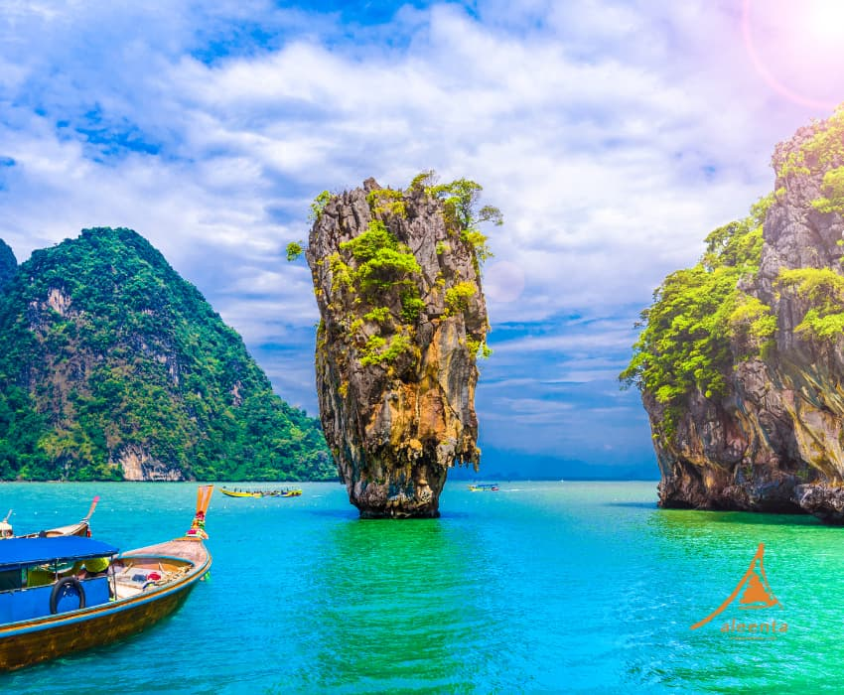

**3N Phuket / 2N Krabi / 2N BKK**

**No Pax : 5**

**Ex Bom to Bom**

**Tour Cost: 99,999 Per Person+ 5% TCS & 5% GST**

**Hotel List**

|  |  |
| --- | --- |
| **Ramada by Wyndham Phuket Deevana Patong/Similar** | 3 Nights |
| **Deevana Plaza Krabi Aonang**  **/Similar** | 2 Nights |
| **Grand Mercure Bangkok Atrium/ Similar** | 2 Nights |

# **Tour Cost Includes**

* Accommodation in Above mentioned hotels
* Flight Cost

**Tour Highlights**

**Phuket: 03Nights**

* **Full Day Phi-Phi Island Tour With Big Boat**
* **(National Park Fees Paid By Guest)**
* **James Bond Island Tour With Big Boat**
* **(National Park Fees Paid By Guest)**
* **Phuket City Tour**

**Krabi: 02 Nights**

* **Full Day 04 Island Tour With Long Tail Boat (National Park Fees Paid By Guest)**

**Bangkok: 02 Nights**

* **Guided City & Temple Tour**
* **Chao Phraya Cruise**
* **Safari World & Marine Park with Lunch**

**Meals : 07 Breakfast**

**Day 1 Welcome To Phuket, Phuket City Tour**

**Welcome To Thailand!!!. On arrival proceed to immigration formalities. Later, proceed For Hotel Check – We Proceed For Phuket City Tour Which Will Include Phuket View Point, Wat Chalong & Phuket's Unique Big Budhha. This Day Is Free For Leisure Or Shopping. Overnight Stay At Hotel.**

**Day : 2 Phi-Phi Island Tour With Big Boat.**

**After An American Breakfast at Hotel. Then Proceed For today we will visit Phi-Phi Island. We proceed to Rassada Harbour to board the boat. Phi-Phi is a group of six islands. The two main islands Phi-Phi Don and Phi-Phi Leh. The larger and inhabited Phi-Phi Don attracts hundreds of visitors to stay on its lovely shores while the smaller uninhabited Phi-Phi Leh hosts stunningly beautiful bays and beaches, including the world-famous Maya Bay, which was the set where “The Beach” movie was filmed. Continue on and enjoy the sight o turquoise water at Loh Samah and Pileh Lagoon. See the Viking Cave where thousands of swallows nest. Get closer to nature when you board the snorkelling boat at Ton Sai Pierand enjoy some swimming or snorkelling in the 1 / 6 beautiful Coral Bay. Later, enjoy your lunch. Rest Of The Day Is Free For Leisure & Own Activity. In evening, .**

**Meal: Breakfast,**

**Day : 3 James Bond Island Tour With Speed Boat**

**After An American Breakfast At Hotel, Today We Will Visit James Bond Island. It's Known As James Bond Island Because It Appeared In 1974's The Man With The Golden Gun. The James Bond Island Tour Includes A Cruise Through Phang Nga Bay - About 25 Kilometres North-East Of Phuket. Admire Stunningly Beautiful Rocky Cliffs Rising Dramatically Out Of The Sea. Paddles Kiss The Shimmering Waters As You Canoe Through Limestone Caves And Mangrove Forests. We Will Depart From Ao Po Pier To Panak Island For Canoeing Into The Ice Cream Cave, The Most Important Cave In Phang Nga Bay With Its Large Stalactites, Stalagmites And Bats. En Route We, Visit Hong Island With Its Famous Limestone Rock For Canoeing Around The Lagoon. Later, Enjoy Your Lunch. Rest Of The Day Is Free For Leisure & Own Activity. Overnight, Stay At Hotel.**

**Meal: Breakfast**

**Day : 4 Phuket – Krabi (By Road : Phuket – Krabi // Approx. 2.30 Hrs.)**

**After An American Breakfast, Check Out From Hotel. Today We Travel From Phuket To Krabi By Road. Sit Back In The Comfort Of Your Coach, As We Drive To Hotel. Check Into Hotel. Rest Of The Day Is Free For Leisure & Own Activity. In Evening, Enjoy Dinner At Restaurant. Overnight, Stay At Hotel.**

**Meal: Breakfast**

**Day : 5 Full Day Krabi Four Island Tour**

**After An American Breakfast At Hotel, Today We Proceed For Krabi Famous 4 Islands Tour By Long Tail Boat. This Is A Popular Day Trip From Ao Nang, Taking In The Group Of Islands Closest To The Coast – The Ones That Can Be Seen On The Horizon From The Beach. The Four Islands Are Koh Poda, Koh Gai (Chicken Island), Koh Tub And Koh Mor; And The Tour Also Stops Off At The Beautiful Phra Nang Cave Beach On The Railay Peninsula. This Beach, Inaccessible By Road , Is Considered To Be One Of The Most Beautiful Strips Of Sand In The World. Koh Poda Is Famous For Its White Beaches And Turquoise Water; The Huge Rock In Front Of It Has Been Featured On Countless Postcards. Picnic Lunch Box Will Be Served At Poda Island. The Cruise Around The “Head” Of Chicken Island, With The Odd Rocky Outcrop That Earned It Its Name Also Makes A Good Photo Op. Fun Fact: Chicken Island Is Really Called “Axe Island” Or Koh Hua Gwan; It Was Dubbed 2 / 6 “That Chicken Island” By Krabi’s First Tourists And The Nickname Stuck. Overnight, Stay At Hotel.**

**Meal: Breakfast**

**Day : 6 Krabi – Bangkok (By Flight: Krabi- Bangkok // Approx. 01 Hrs. 15 Min)**

**Bangkok City Temple Tour After An American Breakfast, Check Out From Hotel. Today We Proceed To Bangkok – The Capital City Of Thailand. En Route, We Visit Gems Gallery Where We Witness A Spectacular Show In Light And Sound Presentation Of The Glittering World Of Gems And Enjoy Shopping Of Precious Stones. Afterwards We Explore Bangkok City, We Visit Principle Buddha And ‘Wat Traimit’ – The Temple Of The Golden Buddha. Later, Check Into Hotel And Relax. Overnight, Stay At Hotel.**

**Meal: Breakfast**

**Day : 7 Safari World & Marine Park**

**After An American Breakfast At Hotel, Today Prepare Yourself For Some Adventure And Entertainment In Safari World And Marine Park – Thailand’s Greatest Open-Air Zoo And Leisure Park. Safari World Covers An Area Of Some 170 Acres And Is Divided Into 2 Parts, The First, Safari Park, Houses A Large Variety Of Animals Like Zebra, Deer, Giraffe, Birds, Tigers, Lion, Bears, Etc. In Natural Habitat. Explore Nature’s Numerous Wonders In Their Original Splendor And Respond The Call Of The Wild, While Remaining In The Comfort Of Our Private Car Or Coach. Witness The Truly Breathtaking Tiger & Lion Feeding Show The Only One Of Its Kind Anywhere In The World. The Second, The Marine Park, Exhibits Marine And Some Rare Animals. You Can Enjoy Performances By Trained Animals Like Dolphins, Birds, Seals And Monkeys. We Also Enjoy Shows Like Orang Utan Monkey Kick Boxing Show, Cow Boy Stunt Show, Sea Lion Show, And Dolphin Show. Stay At Hotel.**

**Meal: Breakfast**

**Day : 9 Back to Home After An American Breakfast At Hotel, Check Out And Transfer To Airport For Your Flight Back Home. Good Times Need Never End! Relive The High Points Of Your Tour. We Are Confident You Will Join Us Again Sometime Soon.**

**Terms & Conditions:**

**Payment Terms : 40000 INR Per Person Deposit Amount At The Time Of Booking & Its Non-Refundable @ Any Circumstances.**

**2nd part of Payment after 15 Days of Booking. (30000 INR)**

**Remaining Payment will clear before 25 Days of Departure dates.**

**ROE will be calculate @ final payment.**

**GST 5 % is applicable on Total Tour Cost.**

**TCS 5 / 20 % is applicable on Total Tour Cost**

**Important Notes:**

**Subject To Surat Jurisdiction.**

**Airlines : We Can Not Make Seat Selection In Group Tour From Our End If Guest Wants To Seats Together Guest Have To Inform At Boarding Counter At Airport For Same. The Internal Airline Used Are LCC, No Food Will Be Served On Board. It Allows Only 20 Kg Check In Luggage And 07 Kg Cabin Luggage. Excess Baggage Charged Will Be Bear By Guest .**

**Meals :**

**There Will Be American Or Continental Breakfast Serve At The Hotel And ENJOY HOLIDAYS. Cannot Make Any Changes In The Breakfast.**

**Lunch/Dinner Wherever Provided On Tour Is Pre-Set Menus By The Restaurants. The Meal Type Selected By The Guest Such As Veg. / Non. Veg. Is Subject To Availability At Restaurants Or Airlines.**

**Child Policy :**

**CNB : 3 - 6 Year Child With No Bed. Please Note There Will Be No Bed For The Child In The Room.**

**CWB : 6 - 11 Year With Bed. There Will Be Extra Bed For The Child In The Room.**

**Hotel Policy :**

**Check In : Check In Time Is 15:00 Hrs.**

**Check Out : Check Out Time Is 11:00 Hrs.**

**Given Package Cost Is On Basic First Category Room.**

**If Guest Want To Upgrade Room Category Supplement Cost Will Be Bear By Guest. If Guest Want To Do Early Check In Or Late Check Out There Will Be Supplement Cost And Bear By Guest**